**6-2 Final Project Milestone Three: System Requirements Model**

John C. Aghadiuno

Southern New Hampshire University

Professor Allyson Heisey

06/08/2018

Table of Contents

Abstract 3

Reporting Requirements 4

Requirements Models 16

Output 16

Input 16

Process 16

Performance 17

Control 17

Data Process Model 17

Data Flow Diagram 17

Data Dictionary 18

Associative Entity 20

Notation Entity 21

Object Modelling 21

Use Cases and Actors 22

Use Case Diagram 23

State Transition 24

References 25

Abstract

The purpose of these requirements is to build a new case reporting system, named ZENO REPORTS, to replace the existing obsolete case management reporting systems (TRIS, CMS and Casey). The intended goals and objectives to be achieved with this document are to define the functional system requirements for accessing and retrieving case data in the ZENO system. The existing systems will continue to be maintained as reference for those metrics that are not reported in the new application. Existing data contained in spreadsheets and other legacy data sources will be cleaned, converted and migrated to the application’s database. This includes the current and historical case data.

Keywords: CMS, TRIS, YAD, CASEY, CMS, Case Management System

# Reporting Requirements

|  |  |
| --- | --- |
| The reporting application will provide UIs for reporting current, and/or historical case data statewide. These reports will also provide additional functionality for filtering and aggregating case data. | |
| **1** | Given a set of filters (e.g., Division, Unit, Office, date) the *Events* screen will return a list or graphical display of aggregate counts for the given filters grouped by filtered agency entities. When comparing multiple date ranges, aggregate counts will be replaced by differences. |
| **2** | Filtering characteristics should include:   * Period (e.g., custom, today, yesterday, last week…)   + From (Starting Date)   + To (Ending Date) * Comparison (i.e., no comparison, compare to previous period, and compare to previous year)   + When not “no comparison”     - From (Starting Date)     - To (Ending Date) * Division (e.g., PD, CAFL, YAD, MH) * Unit (e.g., trial, appeals) * Office (e.g., Lowell District) * Staff Detail |
| **3** | The *Period* filter should present a set of predefined periods including:   * Custom * Today * Yesterday * Last Week * Last Month * Q2 FY2017 * Q1 FY2017 * Q4 FY2016 * Q3 FY2016 . . .   Where the divisions by quarter are the preceding 8 quarters, excluding the current quarter. |
| **4** | The values of the *From* and *To* dates associated with *Period* are automatically set after selecting a period. If they are altered, the *Period* selection is set to *Custom*. |
| **5** | The *Comparison* selection can be:   * No comparison * Custom * Compare to previous period * Compare to previous year |
| **6** | The *Comparison’s* *From* and *To* fields only appear when *Comparison* is not equal to “No comparison” |
| **7** | The values of the *From* and *To* dates associated with *Comparison* are automatically set after selecting a *..previous period* or ...*previous year*. If they are altered, the selection is set to *Custom*. |
| **8** | The span of time covered by the *From* and *To* dates associated with *Comparison* must be the same as that covered by the *From* and *To* dates associated with *Period.* |
| **9** | The *Division*, *Unit*, and *Office* fields should be pulldown menus. |
| **10** | All pulldown values should default to ALL. |
| **11** | The *Division*, *Unit*, and *Office* pulldowns should allow for multiple selections. |
| **12** | The available *Unit* options should be contingent of selected *Divisions*, and the available *Office* options should be contingent on the selected *Unit*. This is to avoid logical impossibilities that would lead to null results (e.g., Division = CAFL and Office = Lowell District). |
| **13** | *Staff Detail* should be a pulldown, defaulting to all, and allowing for multiple selects (e.g., attorney, SSA, investigator). |
| **14** | Filtered results should be displayed in four slices:   * Mixed Division,Unit and Office List * Staff List * Graph * Cases List |
| **15** | The *Mixed Division, Unit and Office List* should display   * A nested list of the selected Divisions, Units and Offices * As well as a TOTALS row at the top, aggregating values for the following rows.   Each row should contain columns noting   * Start: The number of open cases at the Start of the Period * Asd: The number of cases Assigned during the Period that are not Probation or Bail * Prob: The number of Probation cases assigned during the Period * Bail: The number of Bail cases assigned during the Period * Tch: The number of Touched Cases (start + asd + prob + bail) * Clsd: The number of cases that were closed during the Period * End: The number of cases open at the end of the Period. |
| **16** | When fetching search results the system should display a loading message to make clear that a search is underway. Ideally, this would take the form of a progress bar to indicate how much time is left. |
| **17** | *Mixed Division, Unit and Office List* counts should count each individual case, not each time a staffer touches a case. So if two attorneys worked the same case, it would show up only once. |
| **18** | The content of the *Mixed Division, Unit and Office List* is contingent on the filtering selections. |
| **19** | The content of the *Staff List* is contingent on those rows selected in the *Mixed Division, Unit and Office List*. It should be possible to select more than one such row. |
| **20** | The *Staff List* should display rows for each involved staff member with subdivisions for offices. Office subdivisions should not include counts. However, each staff row should include the same columns and counts as the *Mixed Division, Unit and Office List* but tailored for the staff member*.* |
| **21** | The *Staff List*, should count each time a staffer touches a case. So if two attorneys worked the same case, it would show up as a single case in each attorney’s row. |
| **22** | The report will show either *Details* or *Graph* |
| **23** | When *Comparison* is not *No Comparison*, the counts in rows will show the difference between the older period and the newer period. For example, if period 1 had 20 touched cases and period 2 had 19, the displayed number would be -1. |
| **24** | When *Comparison* is not *No Comparison*, the Graph will display lines for period 1 and period 2. |
| **25** | Graphed data will plot counts for the number of open cases. That is, the Y axis should start with the number of open cases at the beginning of the period, going up with newly opened cases and going down with newly closed cases. |
| **26** | The graph will contain data for the most granular selection above. For example, if Lowell District is selected in *Mixed Division, Unit and Office List* and there no selection in the Staff List, the counts will be those of all Lowell District cases matching the filtering criteria. If, however, Attorney Smith is selected in the Staff List, the counts will be those of Attorney Smith’s cases. |
| **27** | The start and end dates on graphed data will be set by the min and max opening dates found in matching cases. |
| **28** | The granularity of dates in graphed data will allow for user editing. *For example, the x axis could show individual days, weeks, months or quarters, depending on the user selection. These delineations would count cases in groupings. So, if the divisions were by weeks, the Y axis would display counts per week.* |
| **29** | The granularity of date data in graphed data should be a function of the difference between the start and end date of the graph. *For example, if the time spans days, the level of detail should be days, if it spans years, quarters or months would be appropriate.* |
| **30** | The *Case Grid* should display a row for each case encompassed by the above selections, with columns for   * Case Number * Docket Number * Client Name * The “most important” charges (limited by space) * The case’s office * The opening date * The attorney(s) on the case * The closing date * An indicator if there was an adverse disposition on any charge |
| **31** | The results should include a *total number of matches* as an output. |
| **32** | When the total number of matches is sufficiently small, there should be the option to output results to a csv or xls file. |
| **33** | When a case number is displayed, it should be a hyperlink to the case’s details as seen in the current system (i.e., CASE, TRIS or CMS). |

# Requirements Models

## Output

* The system must provide UIs for reporting current and historical case data statewide.
* The system must provide functionality for filtering and aggregating case data.
* The system must be simple and intuitive, and unambiguous output.
* The system must provide authentication to access its resource.
* The system must provide authorization and implement access control to its resource.
* The system must provide secure access online and be available to any device.
* The system must allow access to customizable reports based on staff roles.

## Input

* The system must allow for case management by staff.
* The system must store case activity and event logs.
* The system must capture relevant information about staff reporting preferences.
* The system must allow management to assign staff to roles.

## Process

* The system must integrate with the existing case systems.
* The system must be able to generate reports based on user provided metrics.
* The system must be able to pull data from existing systems and aggregate data.
* The system must have built-in algorithms to enforce agency rules and objectives.
* The system must be able to export data in various formats.

## Performance

* The system must be able to scale and support thousands of users simultaneously.
* The system must be able to handle core business processes.
* The system must have a friendly interface, easy to use and accessible on any device.

## Control

* The system must provide a secure single log-in enterprise-wide.
* The system must provide authentication, authorization and access control mechanisms consistent with business rules.
* The system must provide for the security, integrity, reliability, retention and back-up of data in accordance with applicable state laws, governing bodies, industry standards and business rules.

## Data Process Model

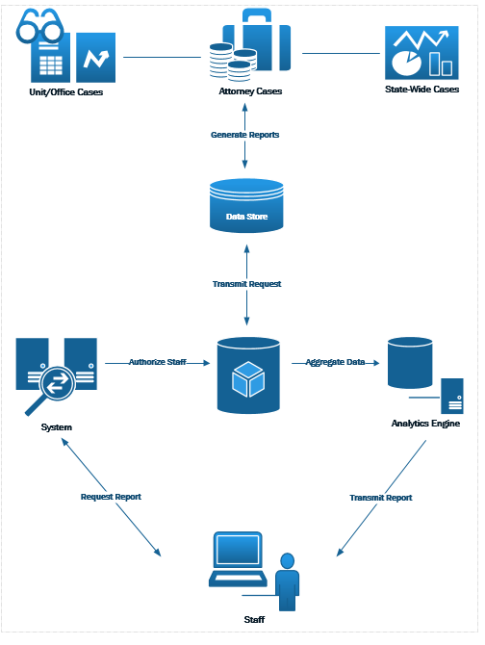

## Data Flow Diagram

## 

## Data Dictionary

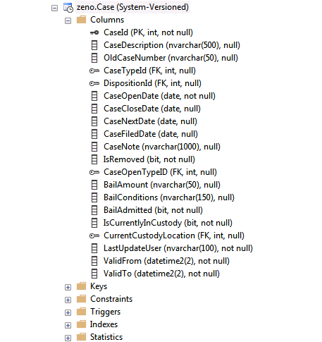

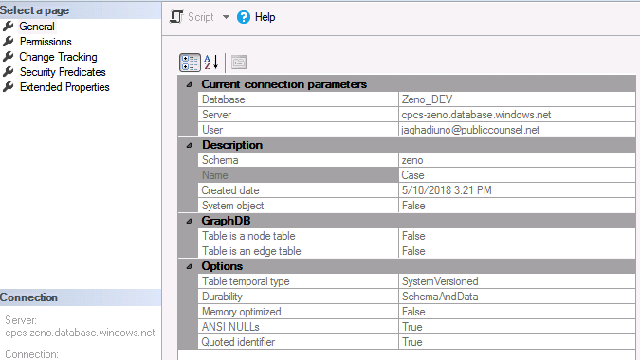

### Associative Entity

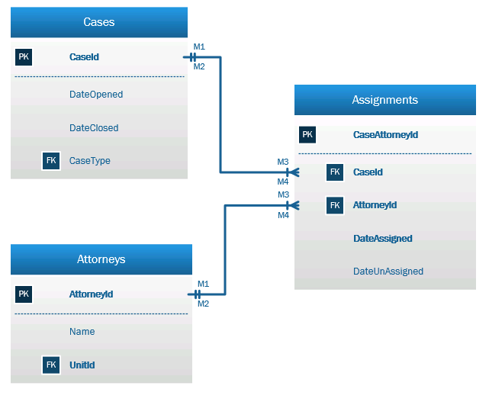

### Notation Entity

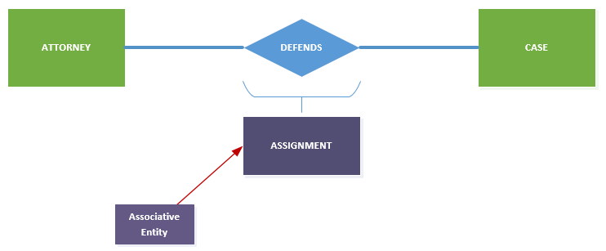

## Object Modelling

Use appropriate object modeling techniques and tools to describe the system requirements.

Every person in the database will inherit from the PERSON class, including attorneys, clients, investigators, judges, defendants, witnesses, etc. While they inherit and share a common set of characteristics, as can be seen in the models below, they can possess their own characteristics.

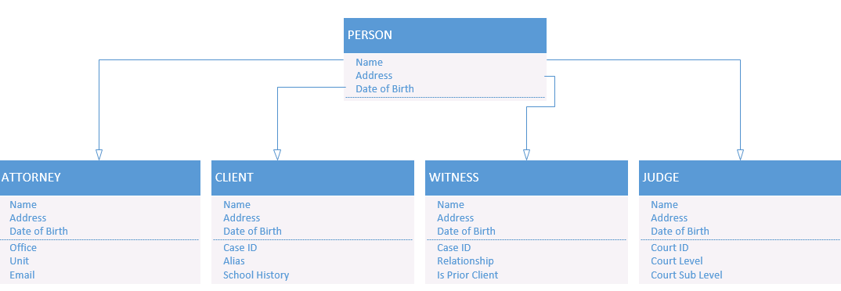

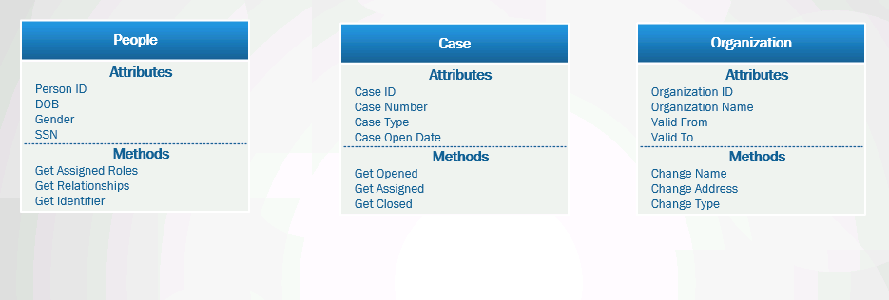

## Use Cases and Actors

Primary use cases and actors for the ZENO system include:

1. ATTORNEY (actor) can VIEW OWN CASE REPORTS (use case).
2. MANAGER (actor) can VIEW ALL CASE REPORTS (use case).
3. OFFICE ASSISTANT (actor) can PRINT CASE REPORTS (use case).

## Use Case Diagram

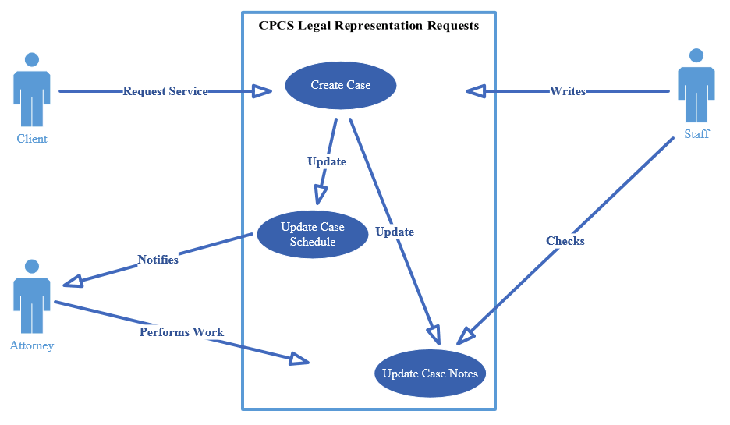

## State Transition

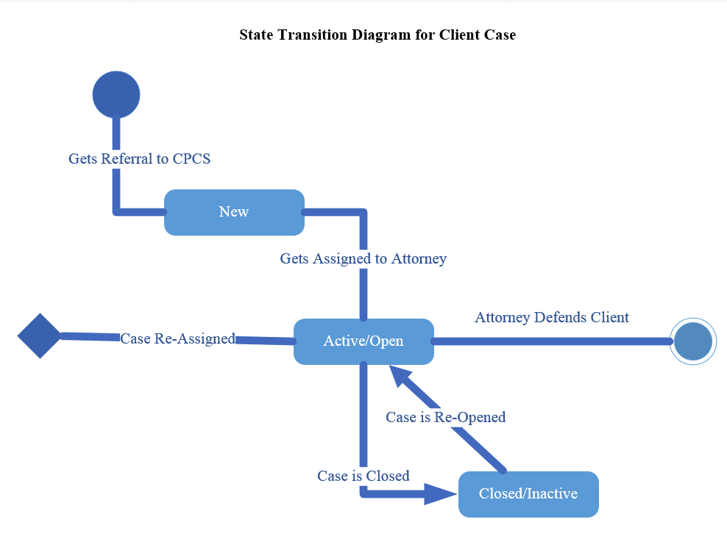

References

Rosenblatt, H., & Scott, T. (2017). Systems Analysis and Design (11th ed.)*.* Retrieved from https://mbsdirect.vitalsource.com/#/books/9781337424202/